myBlueprint:
Student Instructions

Logging in

- Go to myblueprint.ca

- Existing User - Students who already have an account: Type in your email and password. If you forget your password, please click on “Forgot your password” and a new password will be sent to the email you used to register. If you are unable to remember the email you used, then you may have to start over with a new account. Please follow the instructions below to create a myBlueprint account as a “New User.” (I have your Ontario Education Number OEN.)

- New User - Students who need to set up a new myBlueprint account: Have to register as a New User. You should put in the Activation Key twinlakes and then click on Create Account. This will lead you through a series of questions to set up your account. You will need their OEN (Ontario Education Number) to set up your account. (I have these.)

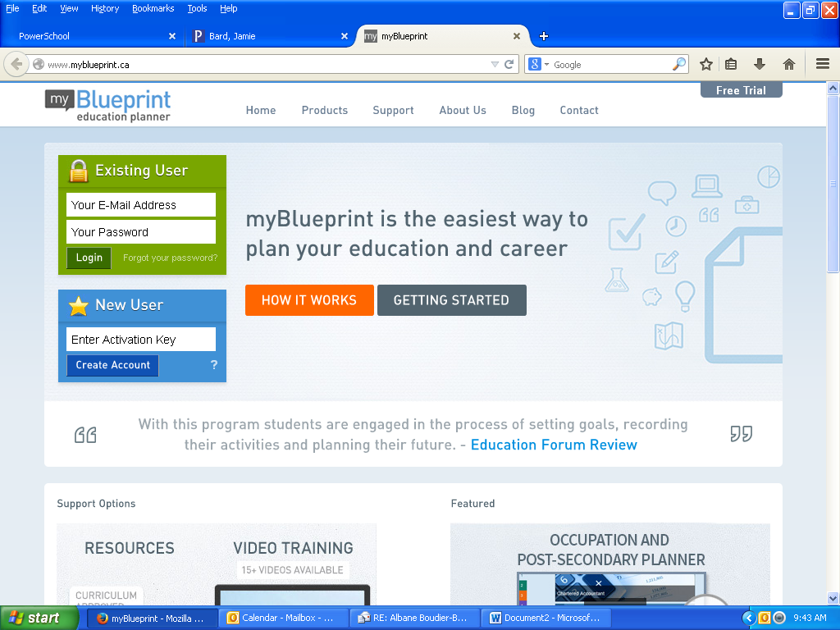

Completing Activities:

- Once you log in, you will be taken to your Home page. (See below)

- Validating Email: You should check the red Alerts on the left hand side. If it says “Email Not Validated” then you should click on this notice to learn how to validate your account through email. If you do not do this, your material may be deleted over the summer.

- IPP (Individual Pathways Plan): You should click on the grey IPP button on the top grey bar to learn which elements of your myBlueprint account you need to finish this year. You should click on the individual components to be taken to the work you need to complete. As you complete the activities, the IPP percentage will incease.

- Further Exploring: Once you have completed 100% of your IPP, you should continue to explore the various components of myBlueprint. If you have planned your classes all the way through to graduation, then you can explore the Pathway Eligibility feature in the High School Planner. It is very useful for learning about the opportunities after high school given your current course selections.

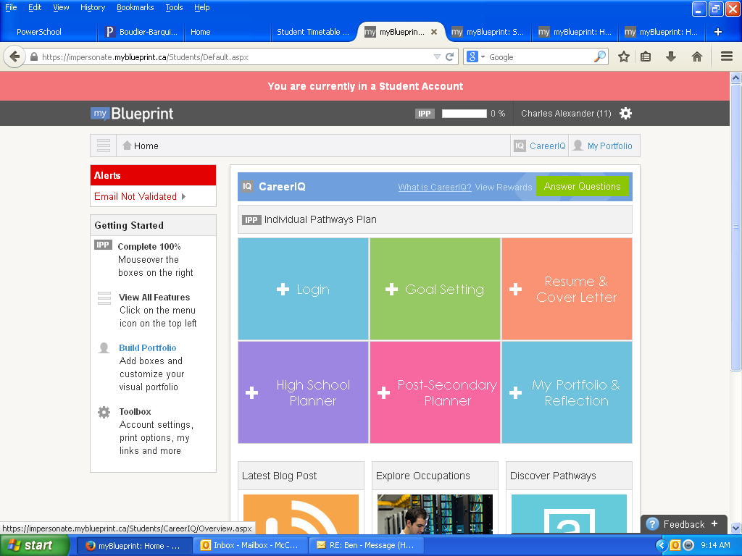

Done everything?

Then you’re awesome!! Then you could also spend some time exploring:
www.electronicinfo.ca to explore university opportunities in Ontario
www.ontariocolleges.ca to explore college opportunities in Ontario
www.tradeability to explore how to get into the skilled trades in Ontario

